AWS WAF deployment with AWS Firewall manager and Terraform

Table of Contents

1.Introduction 1

2.Solution 2

Logging Configuration Option 1 4

Logging Configuration Option 2 4

Logging Configuration Option 3 5

3.Sample Code 5

AWS Firewall Manager WAF policy 5

WAF Automation 5

AWS WAF custom rules and Rule groups 6

Centralized logging 6

Test resources 6

4.Deployment 6

Pre-requisites 7

▪ Join and configure AWS Organizations 7

▪ Member accounts must have AWS config enabled in the region 7

▪ Set the AWS Firewall Manager Admin account in the master account of the organization 7

Input Variables 7

Deployment steps 8

Examples 9

1.Customize vars/PROD.tfvars 9

2.Create the AWS WAF custom rule groups 10

3.Decide which logging solution you are going to use 11

4.Create AWS Firewall Manager Policy 11

4 12

# 1.Introduction

The intention of this document is to provide a clear documentation about the artifacts created to deploy AWS WAF and its configuration using Terraform as IaC provider.

These are the features that you can find and deploy using the templates provided:

* AWS Firewall Manager WAF policy with account and resource scope
* Centralized logging configuration for AWS WAF Web ACLs. 3 options:
  1. Kinesis -> S3,
  2. Kinesis -> (cross account) S3 -> ES (private in VPC)
  3. Kinesis->lambda->ES->Kibana in the same account
* Dashboard using Amazon ElasticSearch
* Automation of AWS WAF IP set with CloudFront IP addresses and AWS WAF IP rule
* Creation of AWS WAF custom rules
* Creation of AWS WAF rate based rules using AWS Firewall Manager Policies

# 2.Solution

This is the diagram that describe the solution:

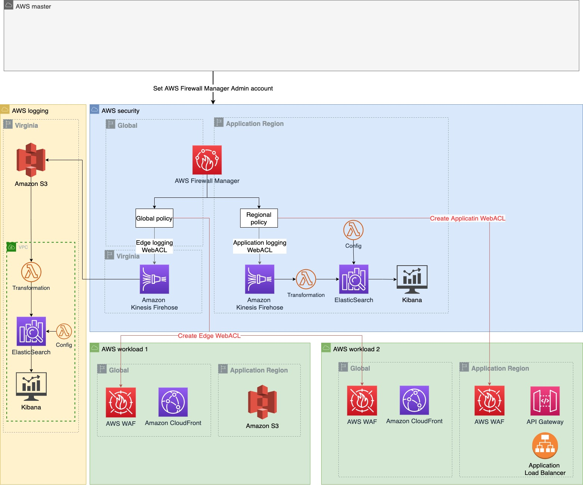

And this is an example of the architecture where 2 AWS WAFs are used, one at the edge network layer and other at the application layer:

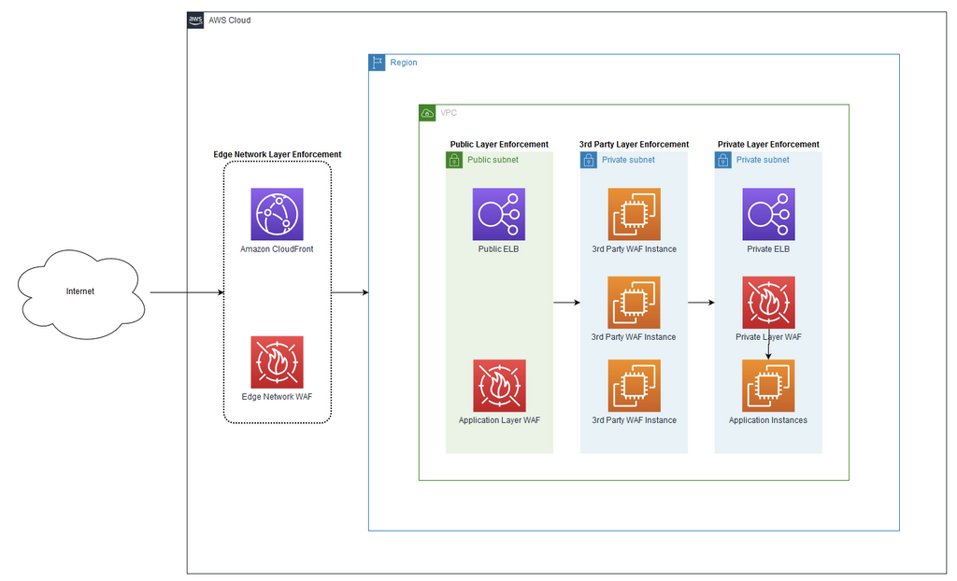

## Logging Configuration Option 1



## Logging Configuration Option 2

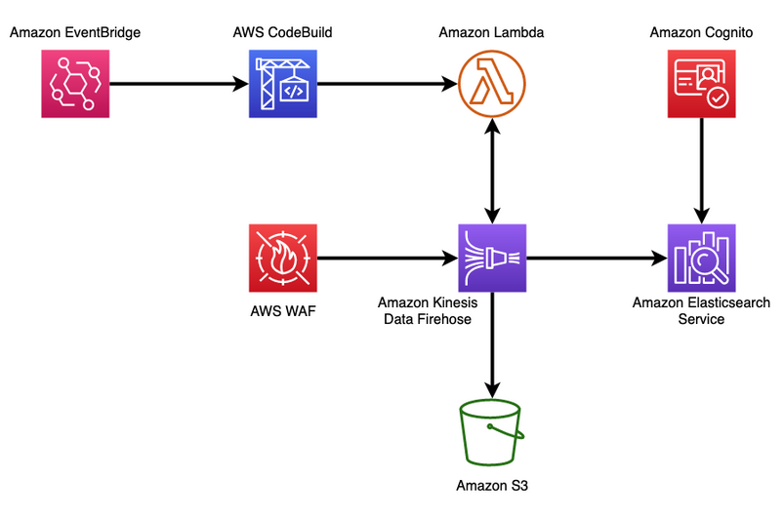

## Logging Configuration Option 3



# 3.Sample Code

## AWS Firewall Manager WAF policy

These are the files with the code to deploy a AWS WAF WebACL using AWS Firewall Manager:

* **1-fwm-global-webacl.tf**: It creates an aws firewall manager policy in the global scope (provider in us-east-1) for the resource type AWS::CloudFront::Distribution. With the input variables you can specify the values for the name, the remediation, Org unit, tags, default action, etc. For the AWS WAF WebACL, the following managed rules have been added: AWS managed rules Core Rule Set, AWS Managed admin protection, AWS Managed IP reputation, known bad inputs set and AWS Managed Bot Control rules (in count mode as an example of how to use it). A rate based rule has been added as a custom rule. For the logging, an Amazon Kinesis Firehose has been created in us-east-1.
* **1-fwm-regional-webacl.tf**: It created an aws firewall manager policy in a region (defined by the provider called security) for the resource type Load Balancer and Api GW. With the input variables you can specify the values for the name, the remediation, Org unit, tags, default action, etc. For the AWS WAF WebACL, the following managed rules have been added: AWS Managed SQL injection rules, AWS Managed Linux rules, AWS Managed Unit rules, AWS Managed PHP rules and AWS Managed Word Press rules.IP allow set (CloudFront IP addresses) has been added as custom rule. For the logging, an Amazon Kinesis Firehose has been created in the region.

## WAF Automation

File “**2-aws-waf-automation-ip.tf**” is using the automation from this [AWS post](https://aws.amazon.com/blogs/security/automatically-update-aws-waf-ip-sets-with-aws-ip-ranges/), but the code has been translated into Terraform. This part created AWS IP set to collect CloudFront IP addresses (IPv4 and IPv6) and allow the traffic in the application from those IP addresses.

## AWS WAF custom rules and Rule groups

You will need to modify the security_service_policy_data value of the AWS Firewall Manager policy to change the current configuration. To create custom AWS WAF rule groups, first set to true the corresponding variable beginning with create_waf_ (example, create_waf_ip_rule_group). That will create the AWS WAF custom rule group, but it will not associate it with the AWS Firewall Manager policy. For that, please update files 1-fwm-*. These are the files where the custom rule groups are defined:

* **3-aws-waf-geo.tf**: It shows how to define a Rule group to apply Geolocation block list. For the example, the country code used is “KP”.
* **3-aws-waf-ip.tf**: It shows how to define an IP Set and rule groups to Allow/Deny those IP sets.
* **3-aws-waf-regex.tf**: It shows how to define a regex pattern set and a rule group that uses it. With the new release of Rate based rules supported by AWS Firewall Manager, this file may need to be updated.
* **3-aws-waf-rate-based.tf and 3-aws-waf-rate-based.yaml**: Terraform does not support rule groups with rate based rules, workaround using CloudFormation template.
* **3-aws-waf-sqli-xss.tf**: It shows how to create a rule group that uses SQLi match statements.

## Centralized logging

There are three options to deploy the centralized logging that you can use and customize.

1. Option 1: **4-fwm-waf-logging-option1.tf**, Amazon Kinesis Firehose with S3 as destination in the same account and with KMS encryption. You can add a lambda to process the logs in Amazon Kinesis Firehose configuration.
2. Option 2: **4-fwm-waf-logging-option2.tf**, Kinesis Firehose -> (cross account) S3 -> ES (private in VPC). Check [this artifact](https://collaborate-corp.amazon.com/nuxeo/ui/#!/browse/default-domain/workspaces/ProServe%20Goldemine%20Workspace/AWS%20WAF%20logs%20into%20a%20cross-account%20private%20ElasticSearch) for more information about this architecture. This architecture uses a CloudFormation stack to deploy Amazon Kinesis Firehose, the IAM role used by Kinesis Firehose and the resources for Amazon Elastic Search. It also creates an ssh tunnel to access the dashboard, following this [documentation](https://aws.amazon.com/premiumsupport/knowledge-center/opensearch-outside-vpc-ssh/).
3. Option 3: **4-fwm-waf-logging-option3.tf**, Kinesis->lambda->ES->Kibana in the same account. This architecture uses a CloudFormation stack defined in the file dashboard.yaml.

## Test resources

Files 5-optional-*.tf create resources that can be protected by AWS WAF with the purpose of testing the AWS WAF WebACL.

# 4.Deployment

## Pre-requisites

### Join and configure AWS Organizations

### Member accounts must have AWS config enabled in the region

### Set the AWS Firewall Manager Admin account in the master account of the organization

## Input Variables

These are some of the important variables, please have a look to the file **0-variables_firewall.tf** for a complete visibility.

For deployment:

* + - **master_region** and **application_region**
    - **create_global_fms_waf_policy**: enable or disable the creation of AWS Firewall Manager WAF policy with GLOBAL scope
    - **create_regional_fms_waf_policy**: enable or disable the creation of AWS Firewall Manager WAF policy with REGIONAL scope
    - **create_waf_geo_rule_group**: enable or disable the creation of AWS WAF rule group with Geolocation (it is not part of AWS Firewall Manager Policy by default)
    - **create_waf_regex_rule_group**: enable or disable the creation of AWS WAF rule group with Regex pattern (it is not part of AWS Firewall Manager Policy by default)
    - **create_waf_geo_rule_group**: enable or disable the creation of AWS WAF rule group with Geolocation (it is not part of AWS Firewall Manager Policy by default)
    - **create_waf_regex_rule_group**: enable or disable the creation of AWS WAF rule group with Regex pattern (it is not part of AWS Firewall Manager Policy by default)
    - **create_waf_sqli_rule_group**: enable or disable the creation of AWS WAF rule group with SQLi rule (it is not part of AWS Firewall Manager Policy by default)
    - **create_waf_xss_rule_group**: enable or disable the creation of AWS WAF rule group with XSS rule (it is not part of AWS Firewall Manager Policy by default)
    - **create_waf_ip_rule_group**: enable or disable the creation of AWS WAF rule group with IP set (it is not part of AWS Firewall Manager Policy by default)
    - **logging_option**: variable that defines the logging resources to create. option1 by default. Available options: option1, option2 and option3.

For **Global Firewall Manager WAF policy**:

* + - global_policy_name: name for the AWS Firewall Manager WAF policy for CloudFront distributions
    - global_policy_remediation_enabled (true by default)
    - global_policy_orgunit_list: org unit of the workload accounts to deploy FM security policy for Shield Advanced
    - global_policy_resource_tags: map of resource tags that aws firewall manager will check to associate web acl
    - global_policy_overrideCustomerWebACLAssociation (true by default)
    - global_policy_default_action (ALLOW by default)

For **regional Firewall Manager WAF policy**:

* + - regional_policy_name
    - regional_policy_remediation_enabled
    - regional_policy_orgunit_list
    - regional_policy_resource_tags
    - regional_policy_default_action

For **logging**:

* + - kinesis_firehose_name: name for kinesis firehose that is the aws waf logging destination (it has to starts with aws-waf-)
    - kinesis_destination_s3_name: name for s3 bucket that is the target of kinesis firehose
    - kinesis_prefix (waf-logs by default)

## Deployment steps

1. Add your details in providers (role to assume), variables and vars/PROD.tfvars
2. Choose which AWS WAF Web Acls you are going to deploy. Use 1-fwm-global and 1-fmw-regional as a template for them. By default, both AWS Firewall manager policies will be deployed, but you can control this using create_global_fms_waf_policy and create_regional_fms_waf_policy vairables. The rule groups used in each policy are not customized with variables because of its format, so you can either deploy the rules that are established at the moment, or make the changes that your solution needs. Choose which AWS WAF custom rules you are going to deploy. Use 3-aws-waf files as templates for them. Add those custom rules to rule groups and modify 1-fwm files.
3. Choose which AWS WAF custom rules you are going to deploy. Use 3-aws-waf files as templates for them. Add those custom rules to rule groups and modify 1-fwm files. You can also control which AWS WAF custom rule group is created using the variables create_waf_*. Those custom rules groups are not part of the AWS Firewall Manager WAF policy by default. Also, the resources in 2-aws-waf-automation-ip.tf and 3-aws-waf-rate-based.tf will be created independently of the variable values. If you do not require those resources, please update the files.
4. Choose your logging configuration using the variable logging_option. Possible values: option1, option2 and option3. Options 2 and 3 use CloudFormation stacks for the deployment and configuration of Cognito and ElasticSearch.
5. Run first terraform plan and terraform apply. For logging configuration, there is a cycle between KMS key policy and Firehose IAM role. Create first one (IAM role) and then edit the other (KMS policy).
6. {optional} If you would like to test these policies and you have other workload accounts, you can deploy CloudFront distribution + S3 bucket and CloudFront distribution + API GW using 5-optional and 6-optional files. Check the providers and the configuration values first.

## Examples

### 1.Customize vars/PROD.tfvars

Example of values for logging option1, creation of both regional and global AWS Firewall Manager policies and creation of a custom AWS WAF rule group with geolocation:

#------------Deployment

master_region = "eu-west-1"

application_region = "eu-west-1"

create_global_fms_waf_policy = true

create_regional_fms_waf_policy = true

create_waf_geo_rule_group = true

create_waf_regex_rule_group = false

create_waf_sqli_rule_group = false

create_waf_xss_rule_group = false

create_waf_ip_rule_group = false

logging_option = "option1"

#------------Firewall manager - policies

global_policy_name = "PoCCFrontPolicy_global"

global_policy_exclude_resource_tags = false

global_policy_remediation_enabled = true

global_policy_orgunit_list = ["ou-xoa2-xsic6u2h", "ou-xoa2-b2faab87"]

global_policy_resource_tags = {

"AWS_WAF" = "Enabled",

"Environment" = "poc",

"Type" = "edge"

}

global_policy_overrideCustomerWebACLAssociation = true

global_policy_default_action = "ALLOW"

regional_policy_name = "ApplicationPoCPolicy"

regional_policy_exclude_resource_tags = false

regional_policy_remediation_enabled = false

regional_policy_orgunit_list = ["ou-xoa2-xsic6u2h", "ou-xoa2-b2faab87"]

regional_policy_resource_tags = {

"AWS_WAF" = "Enabled",

"Environment" = "poc",

"Type" = "edge"

}

regional_policy_overrideCustomerWebACLAssociation = true

regional_policy_default_action = "ALLOW"

#------------Firewall manager - logging

kinesis_firehose_name = "aws-waf-logs-poc"

kinesis_destination_s3_name = "test-waf-logs-poc-s3"

kinesis_prefix = "waf-logs"

s3_delivery_buffer_interval = 60

s3_delivery_buffer_size = 5

DataNodeEBSVolumeSize = 500

ESConfigBucket = "waf-dash-ES-config-1111"

ESUserEmail = "adf@amazon.com"

ES_SSH_tunnel_allowed_CIDR = ["192.168.0.21/32"]

### 2.Create the AWS WAF custom rule groups

For that, you can either uncomment one of the 3- files or use those files as a template to create your own AWS WAF rule groups (and other required resources). This is an example:

resource "aws_wafv2_ip_set" "AllowListsSet" {

provider = aws.security

for_each = var.allow_lists_set

name = "${var.regional_policy_name}-Allowt_${var.allow_lists_set[each.key]["ip_address_version"]}"

scope = "REGIONAL"

ip_address_version = var.allow_lists_set[each.key]["ip_address_version"]

addresses = var.allow_lists_set[each.key]["addresses"]

tags = local.common_tags

}

resource "aws_wafv2_rule_group" "IPRuleGroup" {

provider = aws.security

name = "${var.regional_policy_name}-IP"

scope = "REGIONAL"

capacity = 60

description = "IP Rule Group"

visibility_config {

cloudwatch_metrics_enabled = true

metric_name = "WAFCUSTIPRuleGroupMetric"

sampled_requests_enabled = true

}

rule {

name = "IPAllowListsRule"

priority = 3

action {

allow {}

}

statement {

or_statement {

dynamic "statement" {

for_each = aws_wafv2_ip_set.AllowListsSet

content {

ip_set_reference_statement {

arn = aws_wafv2_ip_set.AllowListsSet[statement.key].arn

}

}

}

}

}

visibility_config {

cloudwatch_metrics_enabled = true

metric_name = "IPAllowListsRule-metric"

sampled_requests_enabled = true

}

}

}

### 3.Decide which logging solution you are going to use

For example, if you choose option 2 (Kinesis Firehose -> (cross account) S3 -> ES in private in VPC), then uncomment file 4-fwm-waf-logging-option2.tf_ and comment the others (option1 and option3). Make sure to use the Terraform provider with the region where the AWS WAF WebACL is going to be deployed.

### 4.Create AWS Firewall Manager Policy

Using files 1-*.tf as templates, you can either modify them or create a new file with your own security service policy data for AWS Firewall Manager policy. This would be an example using the previous AWS WAF custom rule group and AWS WAF Managed rule group AWSManagedRulesSQLiRule Set:

resource "aws_fms_policy" "NonProdApplicationPolicy_regional" {

provider = aws.security

name = var.regional_policy_name

exclude_resource_tags = var.regional_policy_exclude_resource_tags

remediation_enabled = var.regional_policy_remediation_enabled

resource_type_list = ["AWS::ElasticLoadBalancingV2::LoadBalancer", "AWS::ApiGateway::Stage"]

include_map {

orgunit = var.regional_policy_orgunit_list

}

resource_tags = length(var.regional_policy_resource_tags) == 0 ? null : var.regional_policy_resource_tags

security_service_policy_data {

type = "WAFV2"

managed_service_data = jsonencode({

type = "WAFV2",

preProcessRuleGroups = [

{

managedRuleGroupIdentifier = {

vendorName = "AWS",

managedRuleGroupName = "AWSManagedRulesSQLiRuleSet"

},

ruleGroupType = "ManagedRuleGroup",

ruleGroupArn = null,

overrideAction = {

type = "NONE"

} },

{

ruleGroupType = "RuleGroup",

ruleGroupArn = aws_wafv2_rule_group.IPRuleGroup.arn,

overrideAction = {

type = "NONE"

} }],

postProcessRuleGroups = [],

overrideCustomerWebACLAssociation = var.regional_policy_overrideCustomerWebACLAssociation,

defaultAction = {

type = var.regional_policy_default_action

},

ruleGroups = [],

loggingConfiguration = {

#option 2

logDestinationConfigs = [

aws_cloudformation_stack.dashboards_private_kinesis.outputs["KinesisFirehoseDeliveryStreamArn"]

]

}

})

}

}